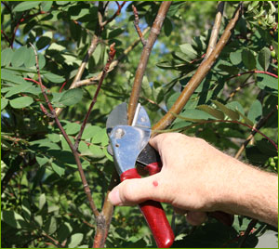  - February 23, 2019  Winter pruning workshop  Learn how and why it is important to prune your fruit plants at this FREE workshop.  Join us on February 23, 2019 at 1:00 pm, at High Rock Nursery to participate in this “hands-on” workshop. We will cover the importance of maintaining your fruit plants through routine pruning as well as offering demonstrations on how this can be done properly.  *Please Register at go.ncsu.edu/2019winterpruningworkshop  **Registration must be made by February 18, 2019 to ensure attendance.  NC State University and N.C. A&T State University are collectively committed to positive action to secure equal opportunity and prohibit discrimination and harassment regardless of age, color, disability, family and marital status, gender identity, genetic information, national origin, political beliefs, race, religion, sex (including pregnancy), sexual orientation and veteran status. NC State, N.C. A&T, U.S. Department of Agriculture, and local governments cooperating. Persons with disabilities and persons with limited English proficiency may request accommodations to participate by contacting Amy-Lynn Albertson, County Extension Director, at 704-216-8970 or amy_albertson@ncsu.edu at least 14 days prior to the event. | 2019 Winter Fruit Plants Pruning Workshop  ____  Learn how to properly prune your muscadine vines, blueberries and blackberries.  ____  Open to the Public  ____  High Rock Nursery  844 JM Penninger Rd. Lexington, North Carolina 27292  ____  February 23, 2019 @ 1:00 PM  Cost: Free!  Hosted by: DAVIDSON AND rOWAN cOUNTY cOOPERTATIVE eXTENSION  301 E. CENTER ST., LEXINGTON, NC  Call: 336-242-2091 if you have any questions.  Davidson County Webpage: https://davidson.ces.ncsu.edu/

