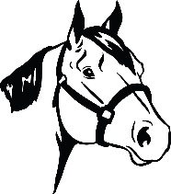
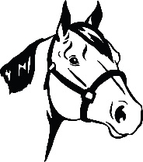
21st ANNUAL DAVIDSON COUNTY FAIR HALTER SHOW
SATURDAY, SEPTEMBER 24, 2022
4-6 p.m.
Director: Gayle Nifong – 336-764-2277

NO Entry Fee – First 25 horses to pre-register will be accepted for the Halter Show.

CLASS LIST:

- Weanling
- Yearling
- Halter Pony
- Mares
- Gelding
- Most Colorful
- AQHA (copy w/ pre-registration)
- Color Breeds
- Showmanship – Youth, 13 & Younger
- Showmanship – Youth, 14-18
- Showmanship – 4-H & FFA
- Western Showmanship – Adults, 19 & Older
- English Showmanship – Adults, 19 & Older
- Costume Class
- Lead Line – 10 & Younger

PREMIUMS
1st 2nd 3rd 4th 5th
Classes $40 $35 $30 $20 $10
Showmanship $25 $20 $15 $10 $5

GUIDELINES
- Most Colorful is for all breeds of horses with NATURAL COLOR.
- Markings to be judged 60% color and 40% conformation.
- Weanlings – weaned between 6 months and one year.
- Yearlings – between 1 and 2 years old.
- Pony – matures less than 56” from withers.
- Mare – female horse over 3 years old.
- Gelding – male horse that has been castrated.
- Color Breeds are Appaloosa, Paint, Pinto, Palomino, Buckskin, or Dunn.
- All Lead Line will receive Blue Ribbons. No premium.

Rules Entering Davidson County Fairgrounds:
NEGATIVE COGGINS MUST BE SHOWN AT GATE!
Horses will be placed in barn between 3:00-3:45 p.m. Show begins at 4 p.m.
Someone MUST stay with your horse at all times.
Limit one horse per participant.
NO STALLIONS

Note: ALL entries must be pre-registered by Friday, September 16 by 4:30 p.m. Entries can be mailed or delivered in person to Sara Drake, 301 E. Center Street, Lexington, NC, 27292 or emailed to sadrake@ncsu.edu. Please call 336-242-2082 to confirm entry was received.

