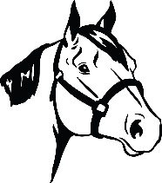
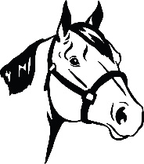
21st ANNUAL DAVIDSON COUNTY FAIR HALTER SHOW
SATURDAY, SEPTEMBER 24, 2022
4-6 p.m.
Director: Gayle Nifong – 336-764-2277
For Official Use Only:

Date Received:

NO Entry Fee – First 25 horses to pre-register will be accepted for the show.

Entry #:

Name of Participant: Age:

Address:
(street) (city, state, zip)

Phone: Email:

Name of Horse: Breed: Age:

Resident of Davidson County: Yes No

Member of: 4-H FFA Name of Leader/Advisor:

PLEASE CIRCLE CLASSES ENTERED BELOW:

- Weanling
- Yearling
- Halter Pony
- Mares
- Gelding
- Most Colorful
- AQHA (copy w/ pre-registration)
- Color Breeds
- Showmanship – Youth, 13 & Younger
- Showmanship – Youth, 14-18
- Showmanship – 4-H & FFA
- Western Showmanship – Adults, 19 & Older
- English Showmanship – Adults, 19 & Older
- Costume Class
- Lead Line – 10 & Younger

Waiver of Liability
The undersigned agrees to release and not hold liable the Kiwanis, Cooperative Extension, or any fair staff for any accident or injury while on the premises provided by Davidson Agricultural Fair. The property owner shall not be held liable for any damage to persons, property, vehicles, or livestock. The visitor/rider/handler certifies that he/she is knowledgeable of risks inherent to the activity of horseback riding and the element of danger in being in the vicinity where horses are stabled, ridden, and cared for.

Davidson County Agricultural Fair reserves the right to remove any persons and livestock who fail to comply with the rules and regulations regarding conduct and safety. No profanity permitted. No alcoholic beverages or drugs of any kind allowed. First 25 horses to pre-register will be accepted for the halter show. One horse per participant allowed.

Signature:

If Under 18, Parent/Guardian Signature:

NEGATIVE COGGINS REQUIRED & MUST BE SHOWN AT THE GATE!

Note: ALL entries must be pre-registered by Friday, September 16 by 4:30 p.m. Entries can be mailed or delivered in person to Sara Drake, 301 E. Center Street, Lexington, NC, 27292 or emailed to sadrake@ncsu.edu. Please call 336-242-2082 to confirm entry was received.

